**The basic design aspects of a zero thrust drone consists of  
  
  
Detailed descriptions are given below:**

**PROPELLERS**

1. **Toroidal**
2. **Zipline**

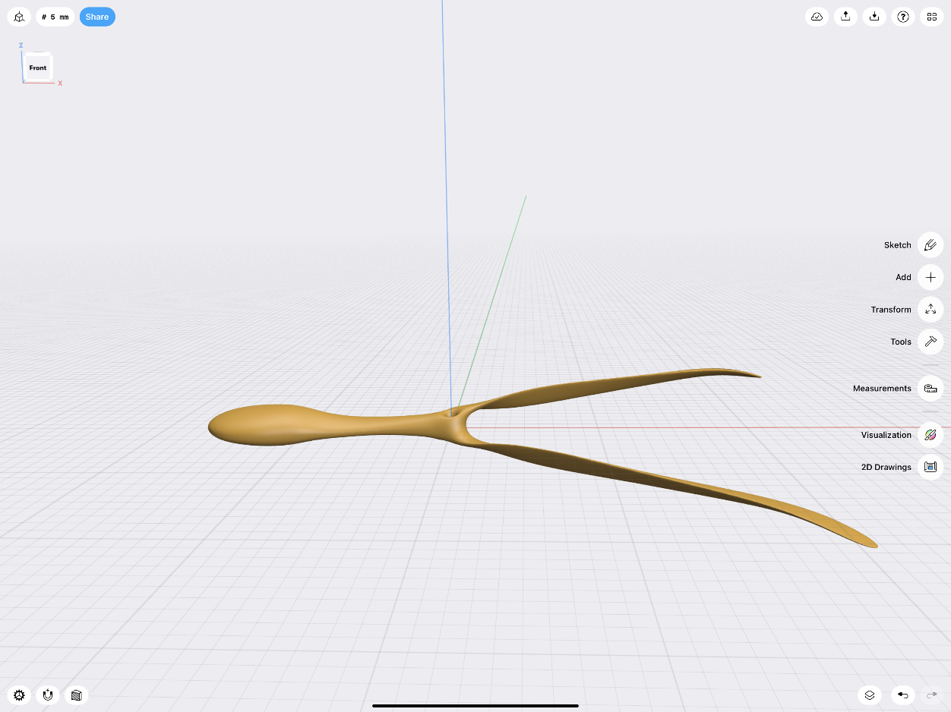

**DRONE FRAME**

**Recommendations for drone frames, considering the need for a quieter drone with less turbulent airflow:**

**INDUSTRIALLY AVAILABLE FRAMES**

**1. FRAME 1**

**- *Material*: Glass fiber and polyamide nylon.**

**- *Weight*: Approximately 282g.**

**- *Dimensions*:**

**- *Wheelbase*: 450mm**

**- *Arm Length*: 220mm**

**- *Center Plate Diameter*: 160mm**

**- *Height*: 55mm**

**- *Motor: **2212 920KV Brushless Motor\***

**- *Torque*: Approximately 0.5 Nm**

**- *Propeller Dimensions*: 10x4.5 inches**

**- *Propeller Type*: Fixed-pitch, low-noise propeller**

**- Propellor dimension: 8-10 inches(estimated)**

**- *Features*: This frame is relatively lightweight and has a simple, aerodynamic design that can help reduce air resistance and noise. Using vibration-damping materials for mounting components can further minimize noise.**

**2. FRAME 2**

**- *Material*: Carbon fiber and glass fiber.**

**- *Weight*: Around 420g.**

**- *Dimensions*:**

**- *Wheelbase*: 500mm**

**- *Arm Length*: 250mm**

**- *Center Plate Diameter*: 200mm**

**- *Height*: 60mm**

**- *Motor: **SunnySky X2212 980KV Brushless Motor\***

**- *Torque*: Approximately 0.55 Nm**

**- *Propeller Dimensions*: 10x4.5 inches or 11x4.7 inches**

**- *Propeller Type*: Fixed-pitch, low-noise propellers**

**- Propellor dimension: 10-12 inches(estimated)**

**- *Features*: This frame’s carbon fiber construction helps absorb vibrations, reducing noise. Its larger size allows for better airflow management, which can decrease turbulence.**

**3. FRAME 3:**

**- *Material*: Carbon fiber.**

**- *Weight*: About 500g.**

**- *Dimensions*:**

**- *Wheelbase*: 650mm**

**- *Arm Length*: 325mm**

**- *Center Plate Diameter*: 240mm**

**- *Height*: 70mm**

**- *Motor: **Tarot 4114 320KV Brushless Motor\***

**- *Torque*: Approximately 1.2 Nm**

**- *Propeller Dimensions*: 15x5.5 inches**

**- *Propeller Type*: Fixed-pitch, carbon fiber propellers**

**Propellor dimension: 12 inches(estimated)**

**- *Features*: This frame is designed for stability and smooth flight. Its foldable design and carbon fiber material help in reducing vibrations and noise. The larger wheelbase also aids in minimizing turbulent airflow.**

**OPEN-SOURCE DRONE FRAMES**

**Thingiverse: A repository of 3D printable designs, including drone frames.**

**DIY Drones: A community of drone enthusiasts sharing open-source designs and projects.**

**GitHub: Some users and organizations share their drone frame designs and related projects here.**

**Here are the recommended BLDC motors for the three drone frames, along with their torque ratings and suitable propeller dimensions and types:**

FRAME 4

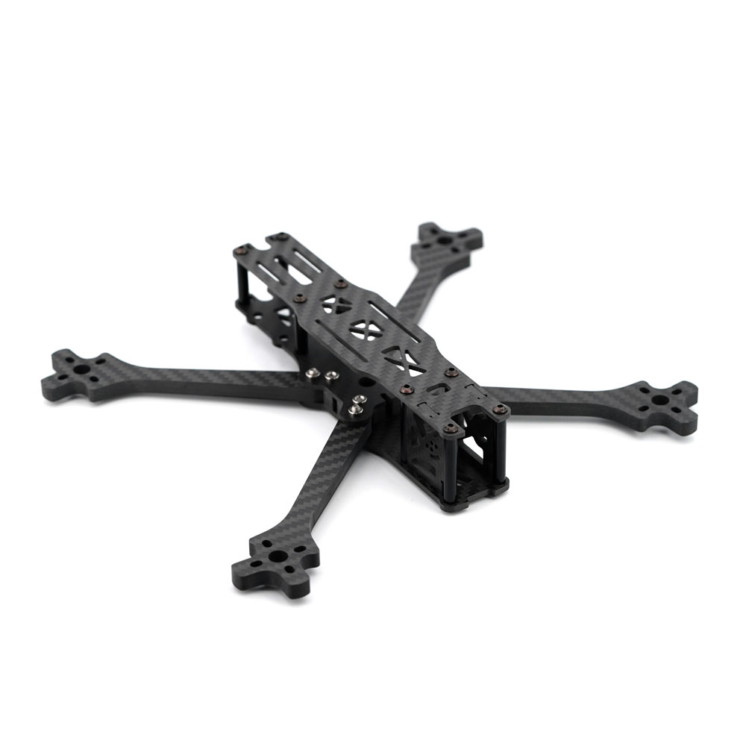

Material:(yet to be decided)

Dimensions:(yet to bedecided)

***CAMERA***

GoPro HERO10 Black

* **Weight**: Approx. 153 g
* **Dimensions**: 71 × 55 × 33.6 mm
* **Features**:
  + 23 MP sensor
  + 5.3K video recording at 60 fps
  + HyperSmooth 4.0 stabilization
  + Waterproof and rugged

Intel RealSense Depth Camera D435i

* **Weight**: Approx. 72 g
* **Dimensions**: 90 × 25 × 25 mm
* **Features**:
  + Depth sensing and RGB camera
  + 1080p video recording at 30 fps
  + Supports computer vision applications
  + USB 3.0 connectivity